Experiment 25: Using Shell Programming in Kali Linux
i) Read a Number and Find Its Square
Aim:
To write and execute a shell script to read a number and find its square using Kali Linux.
Algorithm:
- Start the program.
- Read a number from the user.
- Calculate the square by multiplying the number by itself.
- Display the square of the number.
- Stop the program.
Code:
#!/bin/bash

echo "Enter a number:"
read num

square=$((num * num))

echo "Square of $num is $square"
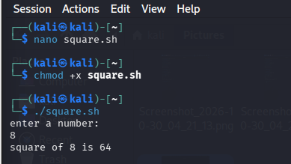
Result:
The shell script was successfully executed in Kali Linux, and the square of the given number was displayed.
ii) Find the Biggest of Three Numbers
Aim:
To write and execute a shell script to find the biggest among three numbers using Kali Linux.
Algorithm:
- Start the program.
- Read three numbers from the user.
- Compare the first number with the second and third numbers.
- If the first number is greatest, display it.
- Otherwise, compare the second number with the first and third numbers.
- If the second number is greatest, display it.
- Otherwise, display the third number.
- Stop the program.
Code:
#!/bin/bash

echo "Enter three numbers:"
read a
read b
read c

if [ $a -ge $b ] && [ $a -ge $c ]
then
echo "$a is the biggest number"

elif [ $b -ge $a ] && [ $b -ge $c ]
then
echo "$b is the biggest number"

else
echo "$c is the biggest number"
fi
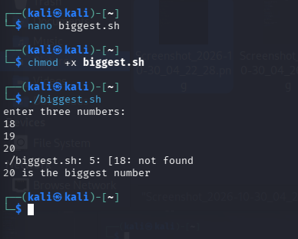
Result:
The shell script was successfully executed in Kali Linux, and the biggest among the three given numbers was displayed.

